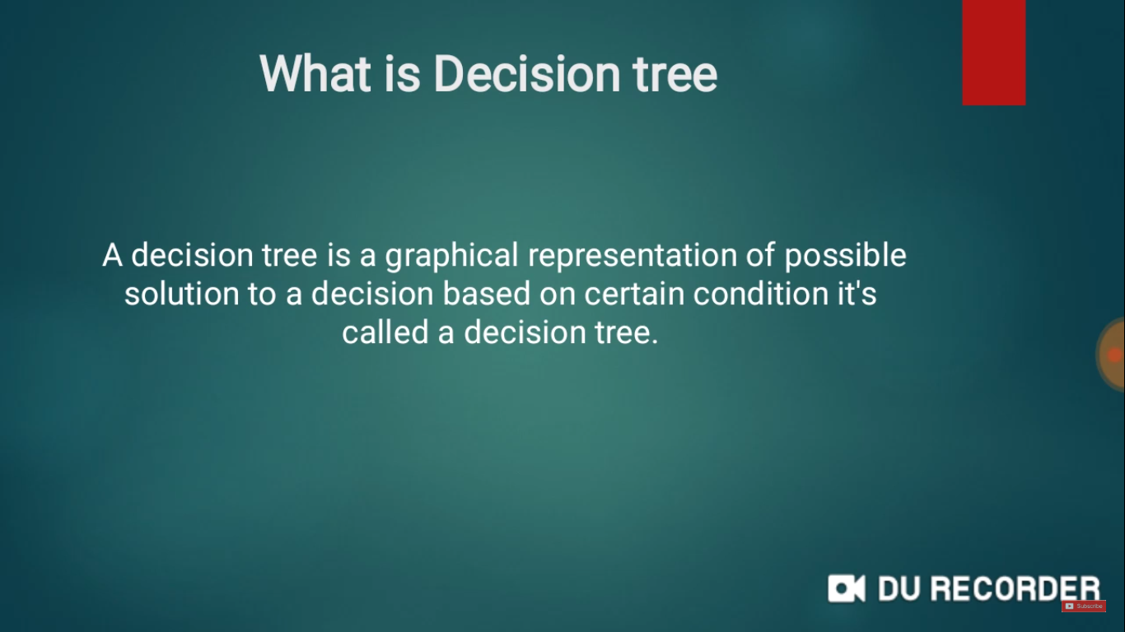

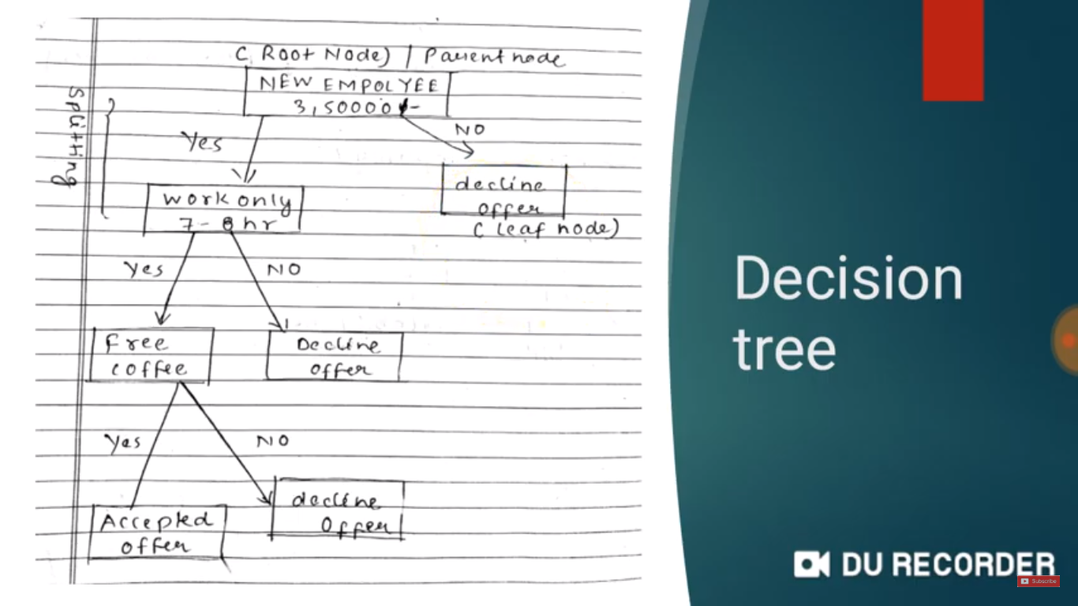

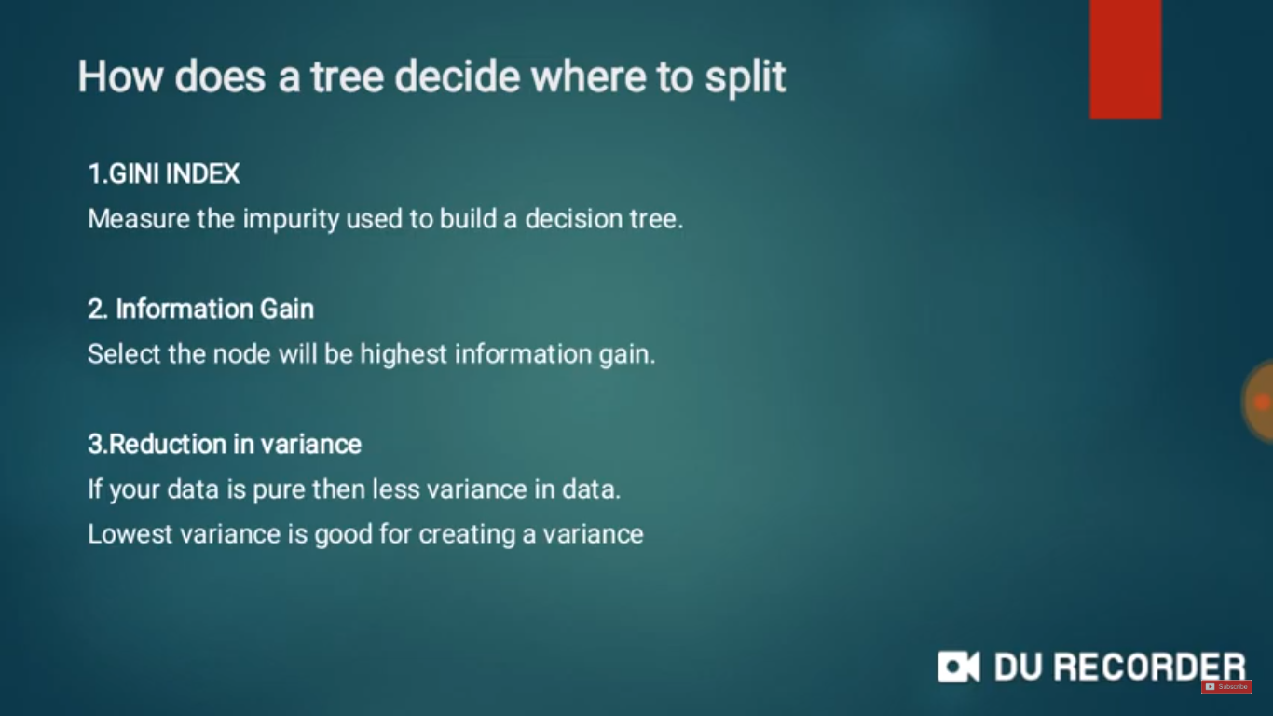

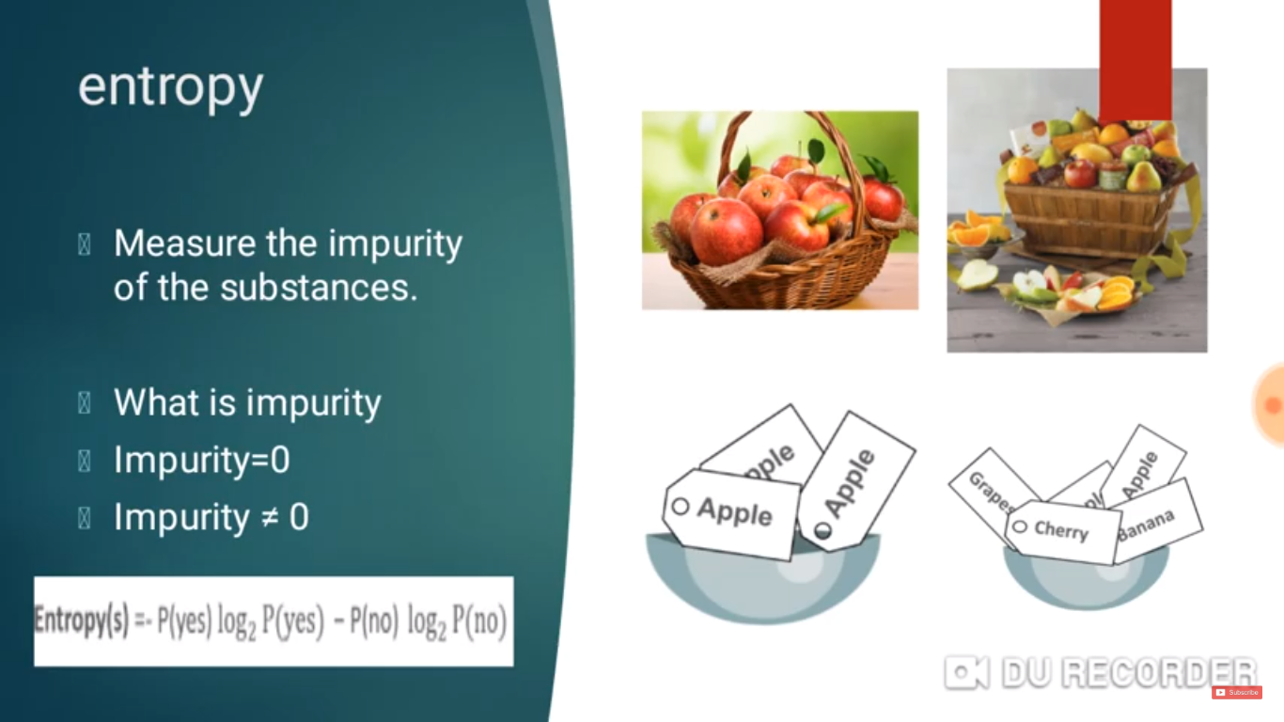

**Entropy(features)= -P(yes)log2P(Yes) -P(No)log2P(No)**

**Entropy(outlook=sunny)=**

**P(yes)**

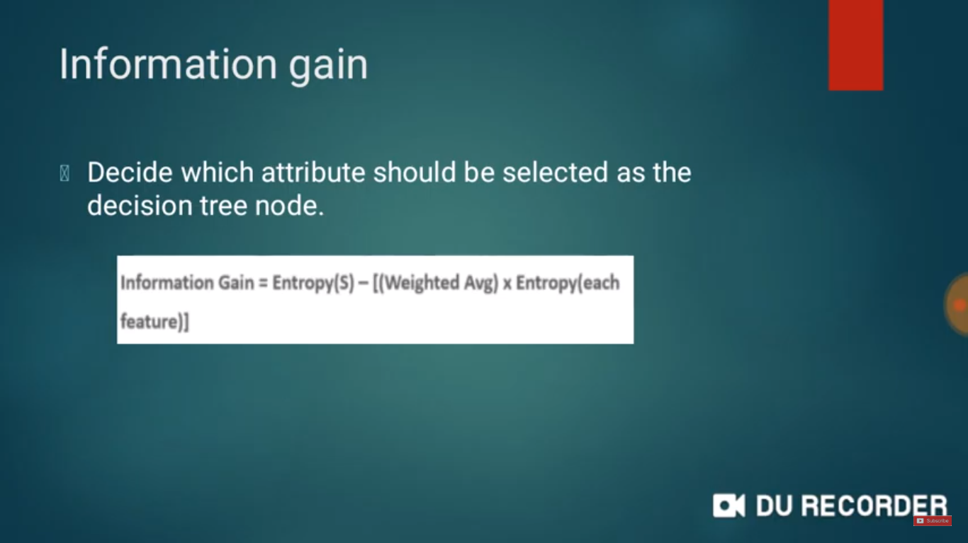

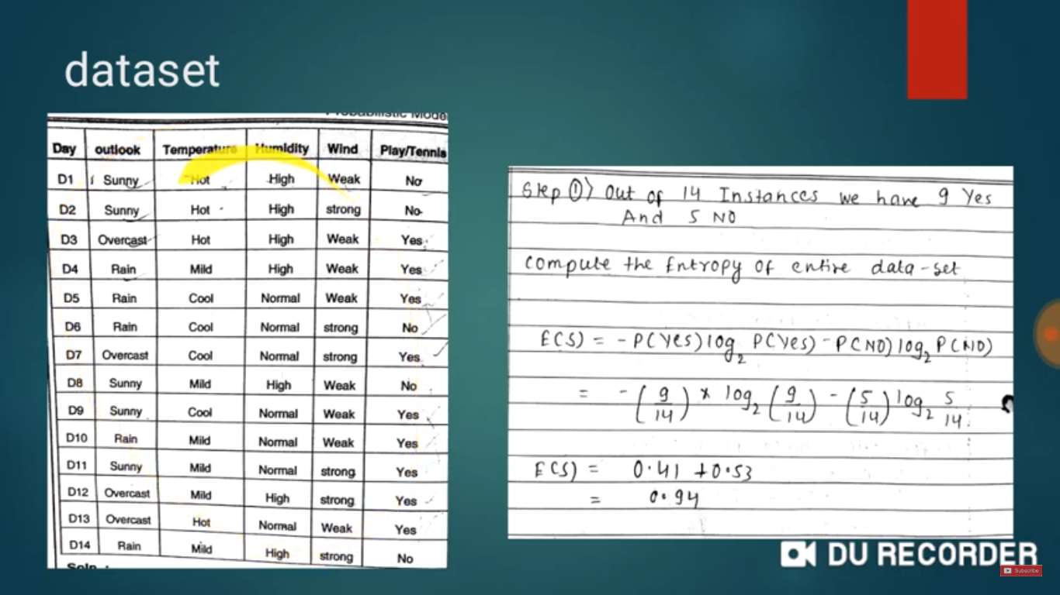

**Find Entropy**

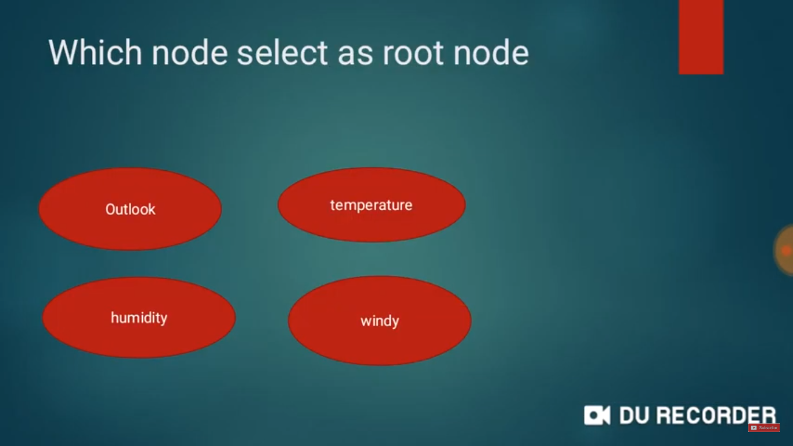

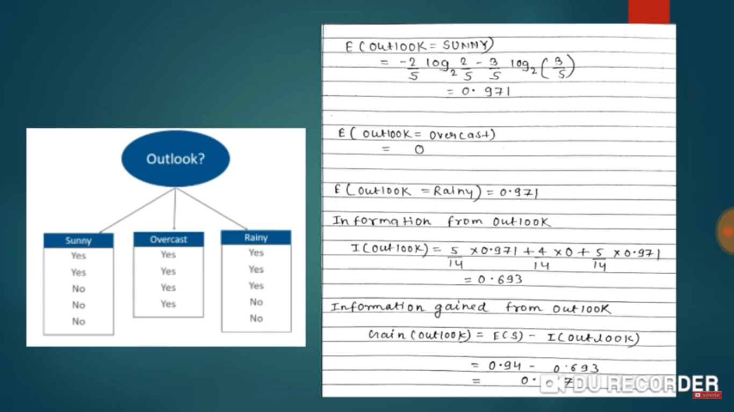

**Entropy(features)= -P(yes)log2P(Yes) -P(No)log2P(No)**

**Entropy(outlook=sunny)= -⅖*log(⅖)-⅗*log(⅗) =0.971**

**Entropy(outlook=overcast)= -4/4*log2(1)-0 =0**

**E(outlook=Rainy)= -⅗*log2(⅗)-⅖*log2(⅖)=0.971**

**Information from outlook=sum of(weight*E(each)**

**Information from outlook=5/14*0.971+4/14*0+5/14*0.971=0.693**

**Information gained from outlook =E(S)-Information(Outlook)**

**Entropy(target)**

**Entropy(Play/tennis)=-P(yes)log2(P(yes)-P(NO)*log2(No)**

**P(yes)=9/14 P(no) =4/14**

**Entropy(Target)=-9/14*log2(9/14)-(5/14)*log2(5/14)=0.94**

**Information gained from outlook =E(S)-Information(Outlook)**

**E(S)=entropy of target**

**IG=0.94-0.693=0.247(outlook)**

